DBMS LAB # 5
Exercise # 1:
QUERY:
SELECT Course.CourseID, Course.CourseName, Prog.ProgramName
FROM Course
JOIN Prog ON Course.ProgramID = Prog.ProgramID;
OUTPUT:
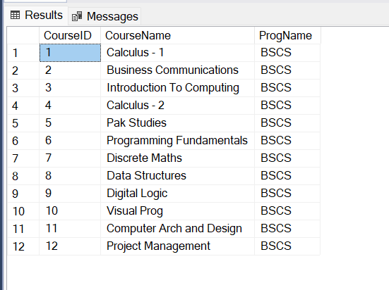

Exercise # 2
QUERY:
SELECT Course.CourseID, Course.CourseName, Prog.ProgramName, Semester.SemesterName
FROM Course
JOIN Prog ON Course.ProgramID = Prog.ProgramID
JOIN Semester ON Course.SemID = Semester.SemID;
OUTPUT:
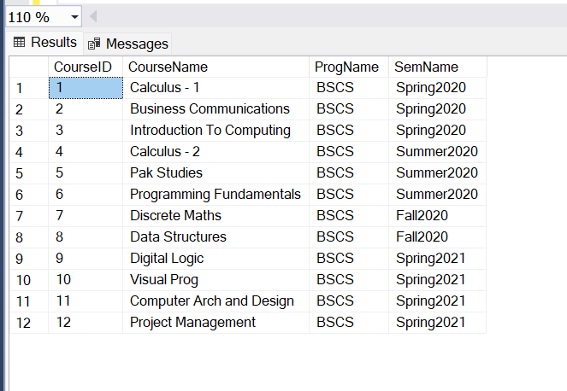

Exercise # 3
QUERY:
SELECT Student.StdID, Student.StdName
FROM Student
JOIN Prog ON Student.ProgramID = Prog.ProgramID
WHERE Prog.ProgramName <> 'BSCS';
OUTPUT:
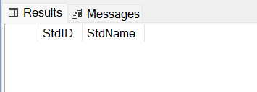

Exercise # 4
QUERY:
SELECT Teacher.TeacherName, Course.CourseName
FROM Teacher
JOIN StdCourseTeacher ON Teacher.TeacherID = StdCourseTeacher.TeacherID
JOIN Course ON StdCourseTeacher.CourseID = Course.CourseID
WHERE Teacher.TeacherType = 'Visiting';
OUTPUT:
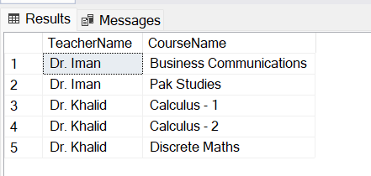

Exercise # 5
QUERY:
SELECT Course.CourseID, Course.CourseName
FROM Course
JOIN StdCourseTeacher ON Course.CourseID = StdCourseTeacher.CourseID
JOIN Teacher ON StdCourseTeacher.TeacherID = Teacher.TeacherID
JOIN Semester ON StdCourseTeacher.SemID = Semester.SemID
WHERE Teacher.TeacherName = 'Dr. Iman' AND Semester.SemesterName = 'Fall2023';
OUTPUT:
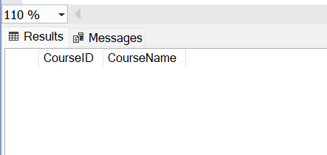
Exercise # 6
QUERY:
SELECT Course.CourseID, Course.CourseName, Teacher.TeacherName
FROM Course
LEFT JOIN StdCourseTeacher ON Course.CourseID = StdCourseTeacher.CourseID
LEFT JOIN Teacher ON StdCourseTeacher.TeacherID = Teacher.TeacherID;
OUTPUT:
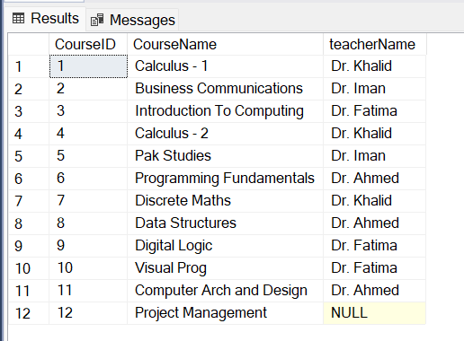

Exercise # 7
QUERY:
SELECT Student.StdName, Course.CourseName
FROM Student
JOIN StdCourseTeacher ON Student.StdID = StdCourseTeacher.StdID
JOIN Course ON StdCourseTeacher.CourseID = Course.CourseID
JOIN Teacher ON StdCourseTeacher.TeacherID = Teacher.TeacherID
WHERE Teacher.TeacherName = 'Dr. Ahmed';
OUTPUT:
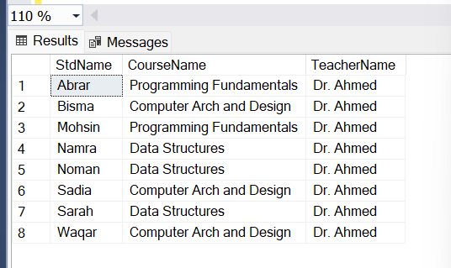

Exercise # 8
QUERY:
SELECT Student.StdID, Student.StdName, Course.CourseID, Course.CourseName,
Teacher.TeacherID, Teacher.TeacherName, Semester.SemID, Semester.SemesterName
FROM Student
JOIN StdCourseTeacher ON Student.StdID = StdCourseTeacher.StdID
JOIN Course ON StdCourseTeacher.CourseID = Course.CourseID
JOIN Teacher ON StdCourseTeacher.TeacherID = Teacher.TeacherID
JOIN Semester ON StdCourseTeacher.SemID = Semester.SemID;
OUTPUT:
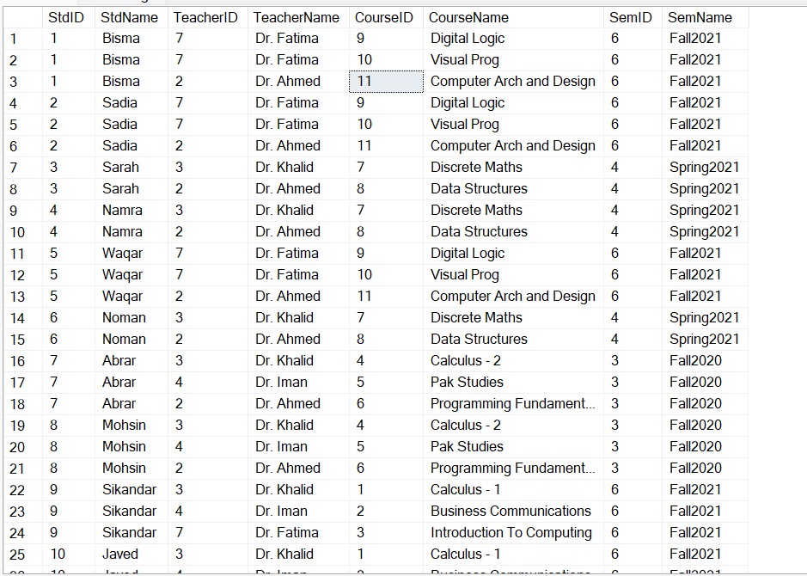

Exercise # 9
QUERY:
SELECT DISTINCT Teacher.TeacherID, Teacher.TeacherName
FROM Teacher
JOIN StdCourseTeacher ON Teacher.TeacherID = StdCourseTeacher.TeacherID
JOIN Semester ON StdCourseTeacher.SemID = Semester.SemID
WHERE Semester.SemesterName = 'Fall2023';
OUTPUT:
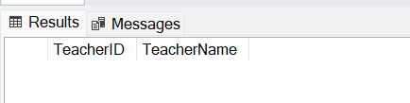
Exercise # 10
QUERY:
SELECT DISTINCT Teacher.TeacherID, Teacher.TeacherName
FROM Teacher
JOIN StdCourseTeacher ON Teacher.TeacherID = StdCourseTeacher.TeacherID;
OUTPUT:
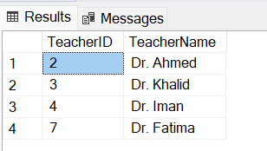

Exercise # 11
QUERY:
SELECT Teacher.TeacherID, Teacher.TeacherName, Course.CourseName
FROM Teacher
LEFT JOIN StdCourseTeacher ON Teacher.TeacherID = StdCourseTeacher.TeacherID
LEFT JOIN Course ON StdCourseTeacher.CourseID = Course.CourseID;
OUTPUT:
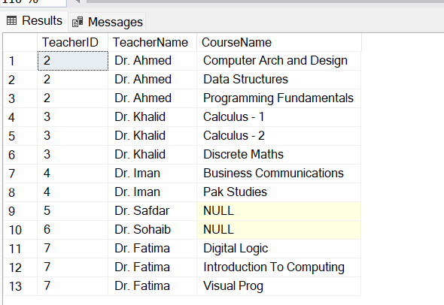
Exercise # 12
QUERY:
SELECT Teacher.TeacherID, Teacher.TeacherName
FROM Teacher
LEFT JOIN StdCourseTeacher ON Teacher.TeacherID = StdCourseTeacher.TeacherID
WHERE StdCourseTeacher.TeacherID IS NULL;
OUTPUT:
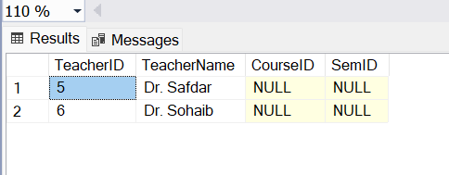

Exercise # 13
QUERY:
SELECT Semester.SemID, Semester.SemesterName, COUNT(Student.StdID) AS EnrolledStudents
FROM Semester
LEFT JOIN StdCourseTeacher ON Semester.SemID = StdCourseTeacher.SemID
LEFT JOIN Student ON StdCourseTeacher.StdID = Student.StdID
WHERE Student.StdID IS NULL
GROUP BY Semester.SemID, Semester.SemesterName;
OUTPUT:
